Source code

**#---------------------------------------------------------------------------**

**# Remote hosts and RMI configuration**

**#---------------------------------------------------------------------------**

**In this section we have to add remote _hosts field with our ipaddress**

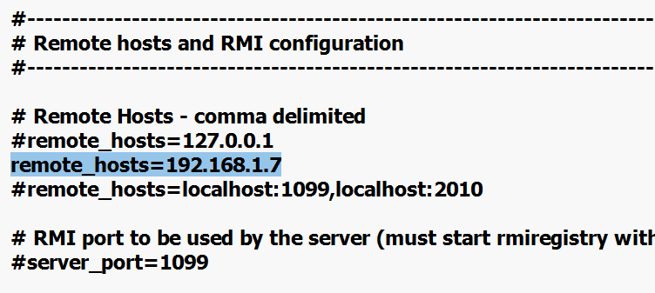

**Next scroll up to the top and search for below entry**

**server.rmi.ssl.disable=false**

**And remove the hash(#) before  server.rmi.ssl.disable=false**

**Change the value of false to true**

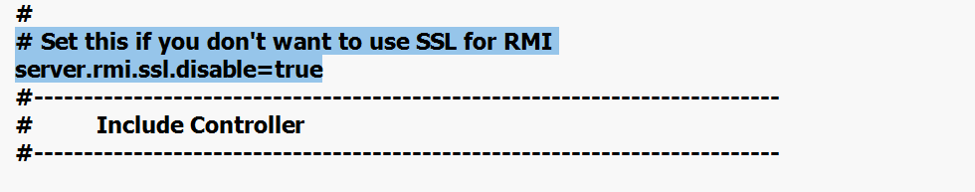

**Save the file and close it.**

**Also close the jmeter and restart it.**